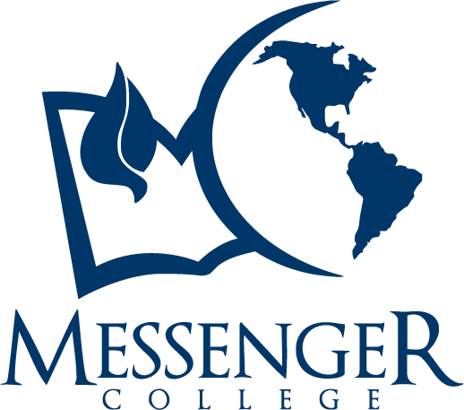
Associate of Arts in Christian Ministry
Degree Completion Worksheet (66 credit hours)
2017-2019 Residential Learning Program

Name: Student ID:

Program Requirements
See the Academic Catalog for program objectives

General Education (39 credit hours)
Course | Prerequisites | Credit Hours | Term Completed
COM1013 Academic Success |  | 3
ENG1013 English Composition I (Min C Grade Req) |  | 3
MATH Elective |  | 3
ENG1023 English Composition II | ENG1013 | 3
COM1023 Speech |  | 3
HIS Elective |  | 3
SCI Elective |  | 3
HUM Elective |  | 3
PSY2013 General Psychology |  | 3
GOV2023 American Government |  | 3
SOC2023 Marriage & Family |  | 3
General Electives (Select Ministry Emphasis Electives or STH3213 and STH3223) | Varies | 6
MC Core (27 credit hours)
Course | Prerequisites | Credit Hours | Term Completed
OTB1013 Old Testament History & Literature |  | 3
PTH1013 Christian Worldview |  | 3
PAS1013 Survey of Church Ministries |  | 3
NTB1023 New Testament History & Literature | OTB1013 | 3
BIB1023 Biblical Interpretation |  | 3
NTB2013 Life of Christ | OTB1013, NTB1023 | 3
ADM2023 Essentials of Leadership |  | 3
HIS2113 History of the Pent/Char Movement |  | 3
PMT Practical Ministry Training |  | 3

AA Completion Sequence – Fall 2018 Entrance Term

Year 1 Fall (16 credit hours) Year 1 Spring (16 credit hours)
COM1013 Academic Success ENG1013 English Composition II
ENG1013 English Composition I COM1023 Speech
GOV2023 American Government SOC2023 Marriage and Family
MATH Elective BIB1023 Biblical Interpretation
OTB1013 Old Testament History & Literature NTB1023 New Testament History and Literature
PMT1011 Practical Ministry Training (1 credit hour) PMT1021 Practical Ministry Training (1 credit hour)

Year 2 Fall (18 credit hours) Year 2 Spring (16 credit hours)
HIS Elective PSY2013 General Psychology
HUM Elective ADM2023 Essentials of Leadership
SCI Elective NTB2013 Life of Christ
PTH1013 Christian Worldview General Elective 1 (Ministry Emphasis Elective or STH3213 Theology 1)
HIS2113 History of the Pent/Char Movement General Elective 2 (Ministry Emphasis Elective or STH3213 Theology 1)
PAS1013 Survey of Church Ministries PMT1041 Practical Ministry Training (1 credit hour)

