EMERGENCY ACTION PLAN
2022-2023

CAMPUS FACILITIES
SAFETY, ACCESS & MAINTENANCE
Messenger College strives to maintain a safe and secure environment for its students, faculty, staff, and the general public who use its facilities. Any building-specific regulations, established by units responsible for those buildings, must be consistent with the regulations established by the Student Development Department. Members of the faculty, staff, and student body should report all crimes, hazards, emergencies, or dangerous situations to the Student Development Department.

During business hours, the College’s academic and administrative building (excluding residential housing facilities) will be open to students, parents, employees, contractors, guests, and invitees. During non-business hours or periods of extended closing, access to all College faculties is restricted to authorized individuals.

The On- Campus Residential Housing facilities entrance is locked 24 hours per day. It is a violation of Community Life standards to open any exterior or interior door(s) or to release the gate code to non-residential housing students.

The Messenger College campus facilities are maintained in a manner to reduce hazardous and unsafe conditions. MC provides 24 hours per day as director of Maintenance that responds to and reports any safety and security concerns to the Student Development department. Anyone recognizing unsafe physical conditions or issues should report them to the Student Development Department.

Building/Property | Address | Contact
MC Learning Center | 2705 Brown Trail. Ste. 401  Bedford, TX 76021 | Director of Student Development  817.554.5950 ext 103.
MC Commons (Residential Housing) | 150 S. Main St.  Euless, TX 76040 | Residence Director  573-338-2069

CAMPUS SAFETY AND CRISIS MANAGEMENT TEAM

The Campus Safety & Crisis Management Team is responsible for providing a safe campus environment. This committee will develop, revise, and maintain a common framework for dealing with crisis situations and educating the campus with safety prevention.

The Campus Safety & Crisis Management team addresses several topics and objectives throughout the year:
- Developing and updating a crisis evacuation plan for residential housing and learning centers.
- Develop a systematic approach for emergency situations that may happen on campus.
- Develop a well-defined communication system in the event of a campus crisis.
- Provide updates to the campus community regarding their safety and timely warnings.
- Provide and update the campus community of campus safety awareness and education.
- Provide training modules for the on-campus community concerning personal safety and awareness.
- Update and distribute the Emergency Action Plan each academic school year.
- Assist in the revision of the Annual Security and Fire Report.
- Meet monthly to discuss and meet the objectives stated above.

EMERGENCY CONTACTS

PERSONNEL | CONTACT | POSITION
Samuel Kinnin | (325) 998-6240 | Director of Student Development
Dalarrie Sage | (573)-338-2069 | Residence Director
Steve Throckmorton | (940) 366-0945 | Facilities Manager

IMPORTANT NUMBERS
PERSONNEL | CONTACT
Bedford Police Department (non emergency) | 817-252-2127
Euless Police Department (non emergency) | 817-685-1526
Euless Animal Control | 817-685-1594
Euless Code Compliance (Pool) | 214-514-1995
Boiler Certification | 512- 463 -6599
Fire Alarm Control Panel, Visionary Systems | 817-488-1433
Kings III, Elevator and Pool Emergency Help | 800-393-5858
Manner Fire Equipment | 817-261-5892
Prime Landscape | 817-461-4000
All Seasons Pest Control | 817-282-2188
SecureOne Tech | 214-514-1995
Euless Code Compliance (Pool) | 817-685-1625

MC COMMONS RESOURCES

Animal Control: Citizens are encouraged to contact Animal Services if they suspect a violation of the animal ordinances. Animal Services will determine if there is a violation according to City Ordinances and notify the owner of the violation. To report a violation of the animal ordinances, submit a request through Access Euless call Euless Animal Services
Contact: Euless Animal Services, 817-685-1594, https://www.eulesstx.gov/departments/animal-services/animal-ordinances

Bedford Police Department (Non-Emergency Number)- 817-252-2127

Boiler Certification of Operation: Boiler room is located on the 2nd floor utility closet. Each year the boiler is inspected. The certification and accident contact information must be placed under glass in a conspicuous place on or near the boiler for which it is issued. Failure to meet this requirement may result in sanctions or penalties.
Contact: csboiler@tdlr.texas.gov; (512) 463 -6599

Certified Pool Operator (CPO): There must be a 3rd party personnel certified to check and maintain chemical levels in the swimming pool. The CPO must have a sign providing an emergency contact name and phone number. Sign must be posted at all entrances.
Contact: Carolyn Dowd at cdowd@messengercollege.edu

Crime Log – The Student Development Department maintains a crime log, which is available for public inspection during regular business hours at the Office of Student Development. The most recent 60-day period of the crime log is available upon request at no cost; portions requested of the log older than 60 days will be available within two-business days. This log contains information about all crimes reported to the Student Development office, including the date the crime was reported; the date and time the crime occurred; the nature of the crime; the general location of the crime; and the disposition of the complaint, if known.
Link: https://impactpcg.forms-db.com/view.php?id=32169

Emergency Call Boxes – These red emergency call boxes are located in the elevators of the Administration Building and one placed in the residential housing facilities by apartment 111. The phones may be used to request help or for any other emergency situation. Phones are tested each month by the Residential Maintenance Worker.
Contact: Kings III, 800-393-5858

Euless Police Department (Non-Emergency Number) – 817-685-1526

Fire Alarm Annual Inspection: Each year the Euless Fire Marshall inspects the MC Commons. The alarm inspection reviews the fire alarm system; fire sprinkler system, back flow, and fire pump system. This needs to be completed prior to the Fire Marshall inspection. The fire alarm control panel is located across from apartment 107. If for some reason the alarm is going off, please contact Visionary Systems.
Contact: Visionary Systems Inc: 817-488-1433 or James Greene from Visionary Systems, (214) 478-5042. Account Number: #3033055
Last dated inspection: April 2022

Fire Extinguisher Annual Inspection: Each year the Euless Fire Marshal inspects the MC Commons. There are four fire extinguishers located on the campus. Two fire extinguishers visible to residents. Two fire extinguishers located in the utility closets. Must check expiration date for extinguishers and communicate to Director of Student Development. Always ask for a loaner tank if any of the tanks need to be serviced.
Contact: Manner Fire Equipment: 817-261-5892
Last dated inspection: September 2021

Fire Marshall Inspection: Each spring/summer the Euless Fire Marshall comes to inspect the MC Commons. This inspection includes:
- Fire Alarm Systems have been inspected prior to the Fire Marshal's inspection.
- Fire Extinguishers have been inspected and tags are placed signifying the expiration dates.
- All screens on the outside/exterior windows of each apartment must be present.
- All smoke detectors work in all apartments, batteries are replaced.
- All the railing around the pool is in place and not broken.
- Boiler room inspected.
- Pool has been inspected.
- No gas, oil based paint or supplies inside The Commons or apartments unless in a fireproof cabinet.

First Aid Kits: These emergency kits are located:
- MC Learning Center – Academic Offices
- MC Commons by Emergency call box & Fire Extinguisher near Apartment 111.

Landscape: Messenger College outsources Prime Landscapes to mow, trim the bushes, and keep up with weekly pool services.
Contact: Prime Landscape, 817-461-4000

Personal Safety Tips Please also keep in mind these personal safety tips provided by the Student Development Department.

- Follow all instructions given by Student Development staff.
- Keep vehicles locked at all times.
- Do not have any valuable insight in your vehicles.
- Keep all apartment doors and windows locked at all times.
- Never sleep in an unlocked room or house.
- Do not keep your residence and vehicle keys on the same ring.
- When entering or exiting the apartments please make sure the gate is secure and locked.
- If there is an unfamiliar vehicle parked on our campus please contact Student Development Staff immediately.
- If there is an unfamiliar person on our campus please contact Student Development Staff immediately.
- Park in well-lit areas.
- Please DO NOT disclose Gate Code to anyone.
- Carry your cell phone with you at all times in case of an emergency.
- Do not let strangers in gated communities use your phone, bathroom or to talk.
- If an intruder awakens you inside your room/apartment, don’t try to apprehend the person. He/she may be armed or may easily arm him/self with something in the room. If this person poses an immediate threat, get out of the room; if not, common sense may dictate pretending you are still asleep.
- If you see a suspicious person or vehicle on campus immediately contact the Euless Police Department. Try to get the license plate number. DO NOT APPROACH THE PERSON OR VEHICLE. You can contact the Euless Police department to report any suspicion and report any crime tips at 817-685-1500 or click here.
- If you are suspicious of a person or activity happening on one of our campuses please contact the Student Development Department at 817-554-5950. If you are a victim of a crime, call 911 immediately. You can contact the Euless Police department to report any suspicion and report any crime tips at 817-685-1500 or click here.

Pest Control: In the case of pests (roaches, mice, or other kinds of bugs) we outsource to Southwest Pest Control. Before calling Southwest Pest it is important that we have documented and extended all measures to try to rid of pests on our own. Southwest Pest Control is available to come quarterly if scheduled, or come for specific apartments on request.
Contact: Southwest Pest Control, 817-294-5498

SecureOne Tech: SecureOne Tech is the company that assists and installs our Security Cameras. There are 6 cameras located on the residential premises. The cameras hold memory for several weeks which means that it is vital that the cameras are reviewed frequently. In the case of an incident that involves the police, the cameras will need to be reviewed and possibly create a file to save the memory of the incident.
Contact: Secure One Tech, secureone.tech@gmail.com; 214-514-1995

Security at The Commons
- The MC Commons has 24 hour gated entry. Gate code must not be disclosed to anyone.
- There is 24-hour surveillance video on the premises. Cameras are checked weekly.
- Concealed and open carry handgun holders are not permitted on any MC Campus Buildings; signs are posted at each entrance.

Security at MC Learning Center
- 24 hour coded entry or designated time for FOB access.
- Two-way Emergency Radio to communicate Emergency situations or Emergency Action Plan to MC Community.
- Concealed and Open Carry Handgun Holders are not permitted on any MC Campus Buildings.

Smoke Detector: The smoke detectors must be inspected annually. Students and the Director of Maintenance should test the smoke detectors upon move in and check out. Semester smoke detector tests are done. Failure to have properly working smoke detectors is a violation and can result in a fine from the city.

Towing: In the case of an unknown vehicle on campus an Incident Report must be filled out including the location, car, and license plates. Residential Directors will then take the necessary steps.

Swimming Pool/Spa Annual Inspection:
Each year or every two years the Euless Code Compliance Department does their Swimming Pool/Spa inspection. We have made major strides since March 2017 to fix the required elements. Nothing can be hanging above the pool at least 25 feet. Pool rules must be posted. The pool is closed based on what the Student Development Department suggests but usually is between November and March. During this time the gate must have a lock on it and a sign indicating the pool is closed must be posted. Please see attached document.
Contact: Euless Code Compliance Department: 817-685-1625

EMERGENCY PROTOCOLS

ACTIVE SHOOTER
Run. Hide. Fight

RUN and escape, if possible.
- Getting away from the shooter or shooters is the top priority.
- Leave your belongings behind and get away.
- Help others escape, if possible, but evacuate regardless of whether others agree to follow.
- Warn and prevent individuals from entering an area where the active shooter may be.
- Call 911 when you are safe, and describe shooter, location, and weapons.

HIDE, if escape is not possible.
- Get out of the shooter’s view and stay very quiet.
- Silence all electronic devices and make sure they won’t vibrate.
- Lock and block doors, close blinds, and turn off lights.
- Don’t hide in groups- spread out along walls or hide separately to make it more difficult for the shooter.
- Try to communicate with the police silently. Use text messages or social media to tag your location, or put a sign in a window.
- Stay in place until law enforcement gives you the all clear.
- Your hiding place should be out of the shooter's view and provide protection if shots are fired in your direction.

FIGHT, as an absolute last resort.
- Commit to your actions and act as aggressively as possible against the shooter.
- Recruit others to ambush the shooter with makeshift weapons like chairs, fire extinguishers, scissors, books, etc.
- Be prepared to cause severe or lethal injury to the shooter.
- Throw items and improvised weapons to distract and disarm the shooter.

BOMB THREAT
If you receive a bomb threat, remain calm and:

1) Obtain as much information as possible:
- Write down the number from where the call is coming
- Write down the exact time of the call
- Write down as accurately as possible the statements made
- Listen to the voice to determine the sex, age, accents, lisps, tone, etc. (Note any distinguishing feature)
- Listen for background noises
- Try to signal a for someone else to also listen on the telephone line, if possible
- Do not hang up and stay on the line a long as possible; wait for the caller to hang up
2) Keep the bomb threat caller talking, and ask as many questions of the caller as you can:
- When will the bomb go off? How much time remains?
- Where is the bomb located?
- What does it look like?
- What kind of bomb is it?
- How do you know about this bomb?
- Why was it placed here?
- Who are you?
- What is your name?
3) Call 911 immediately and then the Director of Student Development at 325-998-6240.
4) Complete a Bomb Threat Checklist form and have it ready, along with your notes from the call, for responding Officers. It is recommended to have a Bomb Threat Checklist form handy, and follow it while receiving the threat.

BUILDING EVACUATION
You should familiarize yourself with the evacuation routes posted in all campus buildings. If an evacuation order is issued for your building, or if it were necessary to evacuate due to an emergency, fully cooperate with Safety and Security/emergency personnel and:
- Take only keys, wallets and essential belongings with you
- If possible wear weather appropriate clothing
- If you are the last one to exit your room close, and lock doors
- Leave the building immediately
- Do not investigate the source of the emergency
- Walk, don’t run, to the nearest exit
- Use stairs, not elevators
- Assist people with special needs
- Get input from the individual how you can help before attempting any rescue technique or giving assistance. Ask how he or she can best be assisted or moved and whether there are any special considerations, methods, or any items that need to be brought with the person during the evacuation.
Individuals who are Blind or have Visual Impairment
- Ask the person who is blind/VI if s/he would like assistance or guidance in leading her/him out of the building to the Emergency Evacuation Meeting Location.
- Give verbal instructions to the person who is blind/VI regarding the safest exit route by using compass directions, estimated distances, and directional terms. (i.e. "from where we're standing, the exit door leading to the main floor of the IMC, 10- 20 feet down the hall on the right past the kitchen. There is a stairwell leading to the side exit onto Wheelock Street. The stairwell has 28 steps and there are handrails on both sides, etc.")
- Do not walk up and grasp the arm of a visually-impaired person and attempt to lead her/him out of the building. First ask if s/he would like to hold onto your arm as you exit, especially if there is debris in the area or you need to exit through a crowd.
- Give other relevant verbal instructions or information (e.g., "elevators cannot be used", "door handle is on the left and the door opens outward", "this exit leads to the eastside of the Collis Center", etc.).
Individuals who are Deaf or Hard of Hearing
- Get the attention of a person with a hearing disability by either touch or by making eye contact.
- Clearly state the situation and reason for evacuation. Have a pen and paper handy to write a brief statement if the person does not seem to understand.
- Offer visual instructions by pointing toward exits for evacuation maps showing the safest exit routes.
- If there is no immediate danger, persons with disability/mobility limitations should shelter in place and call Safety and Security at 817-554-5950 ext. 103 to report location and number of people needing assistance
- If there is imminent danger and evacuation cannot be delayed, the person with a disability should be carried or helped from the building in the best and fastest manner (the person with the disability is the best authority as to how to be moved out of the building)
- If you are unable to evacuate, call Safety and Security at 817-554-5950 ext. 103 and report your location
- As you make your way out, encourage those you encounter to exit as well
- Follow instructions of the Department of Safety and Security or other identified emergency personnel
- Wait for instructions before returning to your building after an evacuation
CYBER SECURITY
Cybersecurity involves preventing, detecting, and responding to cyberattacks that can have wide ranging effects on the individual, organizations, the community, and at the national level. Cyberattacks are malicious attempts to access or damage a computer system. Cyberattacks can lead to loss of money, theft of personal information, and damage to your reputation and safety. Cyberattacks are malicious attempts to access or damage a computer system.

CYBER ATTACKS
- Can use computers, mobile phones, gaming systems, and other devices;
- Can include identity theft;
- Can block your access or delete your personal documents and pictures;
- Can target children; and
- Can cause problems with business services, transportation, and power.
- Use strong passwords.
- Backup all your files.
- Watch for suspicious activity.

CYBER CRIMINALS

WHAT ARE FAKE JOB OR HIRING SCAMS?
Fake Job or Hiring Scams occur when criminal actors deceive victims into believing they have a job or a potential job. Criminals leverage their position as “employers” to persuade victims to provide them with personally identifiable information (PII) or to send them money.

THREAT
Fake Job Scams have existed for a long time but technology has made this scam easier and more lucrative. Cyber criminals now pose as legitimate employers by spoofing company websites and posting fake job openings on popular online job boards. They conduct false interviews with unsuspecting applicant victims, then request PII and/or money from these individuals. The PII can be used for any number of nefarious purposes, including taking over the victims’ accounts, opening new financial accounts, or using the victims’ identity for another deception scam (such as obtaining fake driver’s licenses or passports).
WARNING SIGNS
Cyber criminals executing this scam request the same information as legitimate employers, making it difficult to identify a hiring scam until it is too late. Some indications of this scam may include:
- Interviews are not conducted in-person or through a secure video call.
- Interviews are conducted via teleconference applications that use email addresses instead of phone numbers.
- Potential employers contact victims through non-company email domains and teleconference applications.
- Potential employers require employees to purchase start-up equipment from the company.
- Potential employers request credit card information.
- Job postings appear on job boards, but not on the companies’ websites.
- Recruiters or managers do not have profiles on the job board, or the profiles do not seem to fit their roles.

WHAT TO DO IF YOU ARE A VICTIM
If you are a victim of a hiring scam, the FBI recommends taking the following actions:
- Report the activity to the Internet Crime Complaint Center at www.ic3.gov or your local FBI field office.
- Report the activity to the website in which the job posting was listed.
- Report the activity to the company the cyber criminals impersonated.
- Contact your financial institution immediately upon discovering any fraudulent or suspicious activity and direct them to stop or reverse the transactions.
- Ask your financial institution to contact the corresponding financial institution where the fraudulent or suspicious transfer was sent.

FIRE AND EVACUATION
In the Event of a Fire: Pull the Fire Alarm and Call 911

IF YOU SEE SMOKE OR FLAMES...
- Use “C.A.R.E.”:
  - Contain the fire by closing all doors as you leave
  - Activate the nearest Fire Alarm pull station (Pull stations are located near all building exits)
  - Report the fire by dialing 911
  - Evacuate or extinguish (In most cases, it is best to Evacuate)
- Use a Fire Extinguisher only if:
  - You have been trained.
  - You have your back to an unobstructed exit
  - The fire is contained, and you have reported the fire by Fire Alarm or 911 activation
  - Everyone else has left the area
  - There is little smoke or flames
  - Never fight a fire if:
  - You lack a safe way to escape should your efforts fail
  - It has left its source of origin
  - You are unsure of the type of extinguisher you need or have
  - If you can’t control the fire within 30 seconds, abandon your efforts, close the door(s) and evacuate immediately.

IF TRAPPED IN SMOKE ...
- If you are able, drop to your knees and crawl toward an exit
- Hold your breath as much as possible
- Breathe slowly through your nose using a towel or shirt as a filter.

IF TRAPPED IN A ROOM...
- Close as many doors as possible between you and the fire.
- Place cloth material (wet if possible) around or under the door to prevent smoke from entering the room.
- Be prepared to signal from a window to someone outside or by shouting at regular intervals.
- Place an article of clothing outside a window as a marker for rescue crews.

WHEN TO USE AN EXTINGUISHER
- An extinguisher can be used to suppress a fire that blocks your exit from the building.
- Only use an extinguisher to attempt to extinguish a small fire.
- Remember “P.A.S.S”, the four basic steps to operation a fire extinguisher:
  - P: Pull the pin
  - A: Aim the extinguisher hose at the base of the fire
  - S: Squeeze the lever
  - S: Sweep from side to side
- If the fire is large, very smoky, or rapidly spreading, evacuate the building immediately.

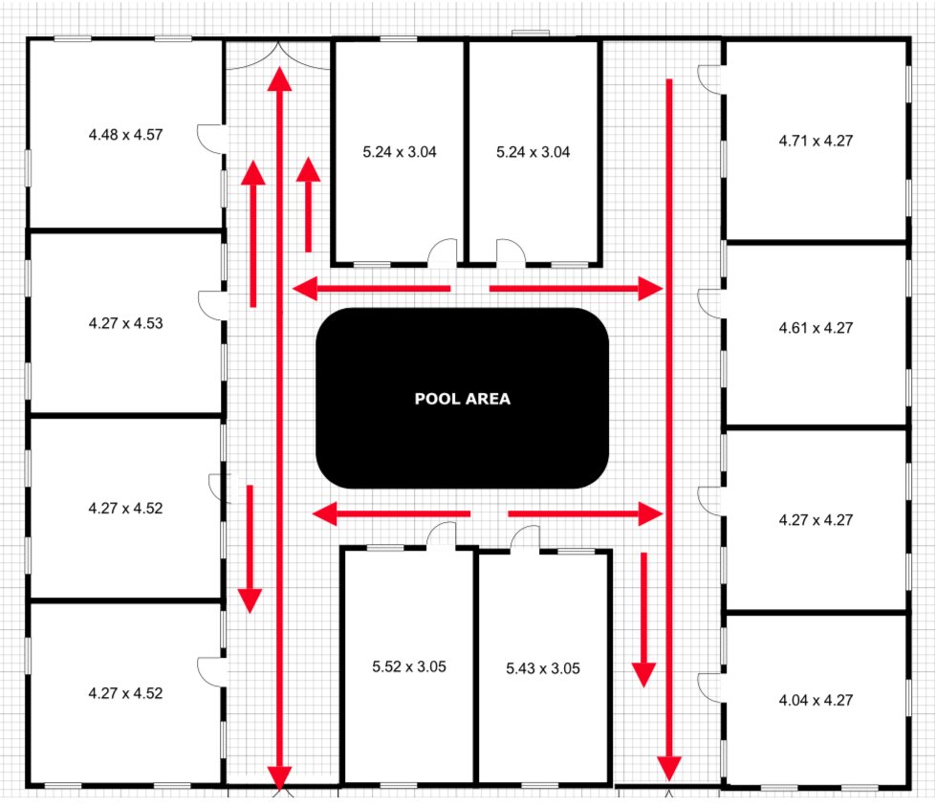

MC COMMONS RETREAT LOCATION – Grassy Areas by Fire Station and Burger King Parking Lot
MC LEARNING CENTER RETREAT LOCATION - Grassy Areas in front of building by road or Rear of Building – Large Football Field

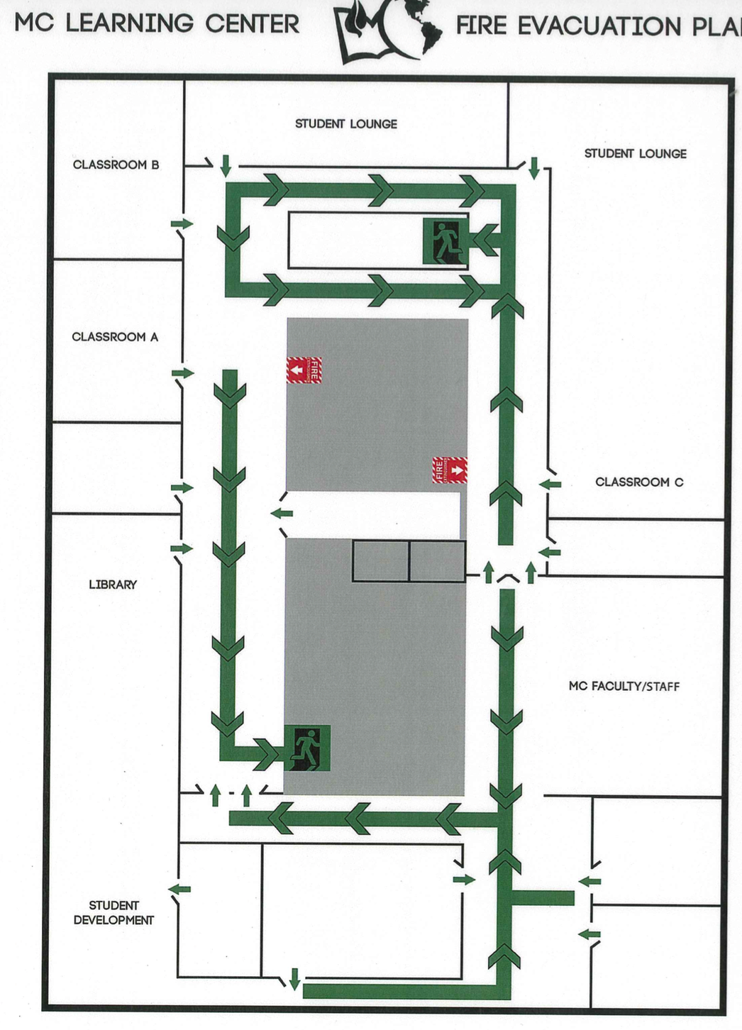

HOSTAGE SITUATIONS
IF YOU BECOME A HOSTAGE:
- Do not try to escape. Be Patient. Time is on your side.
- Follow instructions and be alert (license plate number, street names, try to get a good description of the hostage taker, noting approximate height, weight, age, sex, color, clothing, etc.)
- Avoid arguments and don’t speak unless spoken to.
- Maintain eye contact with the captor and be as friendly as possible.
- Be observant and try to remember all distinguishing characteristics of your captor.
- Be prepared to talk to the police on the phone if a line is patched through to your location.

IF YOU BECOME AWARE OF A HOSTAGE SITUATION:
- DO NOT attempt to apprehend or interfere with the hostage taker except in case of self-protection.
- Building occupants in the immediate vicinity should evacuate the building if at all possible.
- If evacuation of the building will put occupants in harm’s way, occupants should close and lock the doors and remain in place.
- Immediately call 911 and tell the emergency operator about the situation in as much detail as possible. Try to get a good description of the hostage taker, noting approximate height, weight, age, sex, color, clothing, etc.
- If the person is using a vehicle, note the license number, make, model, and color of the vehicle, and the direction of travel.
- Also tell the dispatcher the approximate number of people taken hostage or in the vicinity.
- During normal business hours, call the Student Development Office at 817-554-5950 ext 103. Immediately to inform them of the situation.
- After regular hours and on weekends, call the RD on Duty.
- If applicable, RDs should direct their residents away from the hostage area and remind them not to interfere with law enforcement authorities who respond to the incident.

HOSTILE INTRUDER/ACTIVE SHOOTER

IF A HOSTILE INTRUDER/ACTIVE SHOOTER IS:

OUTSIDE YOUR BUILDING
- Get to a room that can be locked; close and lock windows and doors
- Turn off the lights
- Try to get everyone down on the floor (so that no one is visible from outside the room)
- Call 911. The Dispatcher will ask for, at least, the following information:
a. Your name
b. Location of the incident (be as specific as possible)
c. Number of shooters (if known)
d. Identification or description of shooter
e. Number of persons who may be involved
f. Your location
- Stay in place (calls from unfamiliar voices to come out may be the attacker attempting to lure you)
- Do not respond to any voice commands until you are sure that they come from a Police Officer, or a Campus Staff.

INSIDE YOUR BUILDING
- Exit (get out of) the building immediately
- Notify anyone you may encounter to exit the building immediately
- Call 911. The Dispatcher will ask for at least the following information:
- Your name
- Location of the incident (be as specific as possible)
- Number of shooters (if known)
- Identification or description of shooter
- Number of persons who may be involved
- Your location

If exiting the building is not possible, the following actions are recommended:
- Go to the nearest room or office
  - If you are locked out of all rooms, seek refuge in the nearest restroom, lock yourself in a stall and keep quiet
- Close and lock the door and/or block it (try barricading the door with desks and chairs)
- Cover the door windows
- Call 911 (the Dispatcher will gather information from you)
- Keep quiet and act as if no one is in the room (silence cell phones)
- DO NOT answer the door
- Stay in place (calls from unfamiliar voices to come out may be the attacker attempting to lure you)
- Do not respond to any voice commands until you are sure that they come from a Police Officer, or a Staff member.

ENTERS YOUR OFFICE OR CLASSROOM
- Remain calm
- Dial 911 (if you can’t speak, leave the line open so the Dispatcher can listen to what’s taking place)
- Try to escape, but if unable, you must take action to survive!! Make a quick survival decision, either:
a. Try to negotiate with the hostile intruder/active shooter (perhaps not the most effective measure), or
b. Try to hide; bear in mind that being hidden (i.e. behind a wooden door) is not the same as being covered (i.e. behind a steel door), or
c. Play dead (pretend to be unconscious), or
d. Try to overpower the hostile intruder/active shooter by force (use anything at your disposal and fight for your life);
Only you can decide if this is something you should do
- If someone other than yourself acts to overpower the hostile intruder/active shooter it is recommended that you assist, as this will increase the chances of success and survival. Again, only you can decide if this is something you should do

If the hostile intruder/active shooter leaves your area, and as soon as it is safe to do so:
- Close and lock the door and/or block it (try barricading the door with desks and chairs)
- Call 911 (if not on the line already)
- DO NOT answer the door and stay in place behind cover
- DO NOT respond to any voice commands until you are sure that they come from a Police Officer or staff member

If you decide to flee during a hostile intruder/active shooter situation:
- No matter what the circumstances, make sure you have an escape route and plan in mind
- Do not attempt to carry anything while fleeing
- Do not attempt to remove injured people (leave wounded victims where they are and notify authorities of their location as soon as possible)
- Move quickly, keep your hands up high and visible
- Follow the instructions of any Police Officers you may encounter

WHAT TO EXPECT FROM RESPONDING POLICE OFFICERS
Police Officers responding to an active shooter are trained in a procedure known as "Rapid Deployment" and proceed immediately to the area in which shots were last heard. Their purpose is to stop the shooting as quickly as possible. The first officers to arrive will not stop to aid injured people; rescue teams composed of other officers and emergency medical personnel will follow the first officers after areas have been secured to treat and remove injured persons.
Please understand that the police will be treating all those they encounter (including you) as possible suspects. When you encounter the police:
- Remain calm
- Do as the officers tell you
- Put down any bags or packages you may be carrying
- Keep your hands up and visible at all times
- If you know where the hostile intruder/active shooter is, tell the officers
- Once out of harm’s way remain at whatever assembly point authorities designate
- Keep in mind that the entire area is still a crime scene; police will usually not let anyone leave until the situation is fully under control and all witnesses have been identified and questioned
- Do not leave until you have been interviewed and released

MEDICAL EMERGENCY

If someone is injured or becomes ill:
- Stay Calm
- Dial 911 and explain the type of emergency, the location, condition, and number of victims
- Let the dispatcher know of any safety hazards - chemical spill, fire, fumes, etc.
- Do not hang up unless told to do so by the dispatcher
- Do not move the victim unless there is danger of further injury if s/he is not moved
- Render first-aid or CPR only if you have been trained
- Do not leave the injured person except to summon help
- Comfort the victim until emergency medical services arrive
- Have someone stand outside the building to flag down the ambulance and/or Safety and Security when they reach the vicinity

NATURAL DISASTERS
Floods
Minor or area flooding on campus could occur as a result of a water main break, loss of power to sump pumps, or major multiple rainstorms. MC Staff monitors the National Weather Service, and other emergency advisory systems to stay abreast of weather and alert related conditions and will provide instructions should they be necessary. For imminent or actual flooding, and only if you can safely do so:

- Secure vital equipment, records, and other important paper
- If present in your area, report all hazardous materials (chemical, biological, and/or radioactive) to the local authorities and the MC Staff on call
- Move to higher, safer ground
- Shut off all electrical equipment
- If in a lab, secure all laboratory experiments
- Do not attempt to drive or walk through flooded areas
- Wait for further instructions on immediate action from Safety and Security
- If the building must be evacuated, follow the instructions on Building Evacuation
- Do not return to your building if you have been evacuated by flooding until you have been instructed to do so by College personnel
- If you are assisting with flood cleanup, report immediately to Environmental Health and Safety any oil, chemical, or radioactive materials suspected of mixing with flood waters
Tornadoes
A “Tornado Watch” means that tornadoes could potentially develop. A “Tornado Warning” means a tornado has actually been sighted. If you see a tornado, report it immediately by calling 911, and seek shelter or safety:
- Go to a basement, underground excavation, or lower floor of interior hallway or corridor (preferably a steel-framed or reinforced concrete building)
- MC Commons – Head to Apartment 106 (the Nest), get to a lower, interior apartment.
- MC Learning Center – Evacuate to the basement without using the elevator.
- Seek shelter under a sturdy workbench or heavy furniture if no basement is available
- Listen for reports and siren/public address announcements
- Avoid:
  - Top floors of buildings
  - Areas with glass windows or doors
  - Auditoriums, gymnasiums, cafeterias, or other areas with large, free-span roofs
- If out in the open
  - Cars- Do not wait out the storm in a car; cars are not safe in tornado
  - Move away from the path of the tornado at a right angle direction
  - Lie flat in the nearest depression, ditch, or ravine if there is no time to escape
Winter Storm
Although Texas gets cold weather often, it is not typical to have wintery weather or wintery storms with freezing temperatures for multiple days. Winter storms can bring extreme cold, freezing rain, ice, snow, high winds, or a combination of all of these conditions.
If a winter storm is expected there are a few things to take into consideration

For Preparation of incoming storm:
- Inform students, faculty, and staff of potential weather conditions and direct them to resources that will keep them updated during the storm
- Sign up for local alerts and warnings
- Create and test emergency communication plan(s)
- Stock up on emergency supplies

Tips for students and staff living at The Commons:

- Turn The Heat On: Make sure the heat is on and kept no lower than 60 degrees. Heat can help prevent pipes from freezing, and if pipes freeze and burst, it can cause a lot of water damage to the property and to your possessions.
- Allow the Faucet to Drip: Set the hot and cold faucet drip slightly. Allowing the faucet to be open like this relieves pressure in the system. If a pipe freezes, it is actually the pressure that is created between the blockage and the faucet that will cause the pipe to burst. Allowing the faucet to be open will prevent this pressure from building up and thus keep the pipe from bursting
- Keep Interior Doors Open- Pipes are often located in the cabinets. When the temperature drops, it is a good idea to keep cabinet doors open so that the heat from the rest of the house can keep the pipes warm as well. This is especially important if the plumbing is located on an outside wall. You should also keep all interior doors open so that the heat can flow throughout the home.
- Stay Warm- Bundling up with extra layers, using a space heater or an electric blanket is a great way to stay extra warm. Remember, students are allowed to use and own personal space heaters at The Commons as long as they have the safety hazard feature button underneath the unit. All fans and space heaters must be plugged directly into a wall or surge protector strips.

During and After Winter Storm
- Stay indoors and off the roads. If you must drive, keep emergency supplies in your car.
- Close off rooms to consolidate and retain heat
- Dress in layers, and use blankets to stay warm.
- Limit your time outdoors, and stay dry.
- Only drive if necessary. Remember that roads in Texas are not prepared for ice or snow conditions.
- Monitor local news and alerts for emergency information and instructions

Earthquakes
Earthquakes are more common in the western United States.
In the event of an earthquake:
- Stay away from large windows, shelving systems, or tall room partitions
- Get under a desk, table, door arch, or stairwell
- If none of these is available: move against an interior wall and cover your head with your arms
- Remain under cover until the movement subsides
- After the shaking stops, survey your immediate area for trapped or injured persons and ruptured utilities (water, gas, etc.)
- If damage has occurred in your area, inform RD.
- If it is safe to do so, remain at your location and await further instructions from College personnel
- Do not evacuate until instructed by emergency personnel
- Laboratory personnel:
- Exit the lab to the corridor
- Duck and cover near an interior wall
- If out in the open:
- Stay in an open area away from buildings, power lines, trees or roadways
- If in a car, pull over and stop. Do not park under an overpass or near a building. Be cautious about driving again, in the event roads are damaged
After an earthquake:
- Put on enclosed shoes to protect against broken glass
- If the power is out use a flashlight. Do not light a match or candle
- Be alert for safety hazards such as fire, electrical wires, gas leaks, etc.
- Check on others. If there are injuries or other urgent problems, report them to RD or Community Life Coordinator.
- Give or seek first aid. Assist any disabled persons in finding a safe place for them
- Evacuate if the building seems unsafe or if instructed to do so:
  - Use stairs, not elevators
  - Unplug small electrical appliances
  - Bring keys, purses, wallets, warm clothing
- Be prepared for aftershocks
- Cooperate with emergency personnel, keep informed, and remain calm

Hurricanes

Hurricanes are a tropical cyclone that can hit along any U.S. coast or in any territory in the Atlantic or Pacific oceans. Hurricanes are dangerous and can cause major damage because of storm surge, wind damage, and flooding. Although Messenger College is not close to the gulf and at risk for a hurricane, it is possible that the residual effects of the storm could mildly affect the greater DFW area.

For Preparation of incoming storm:
- Inform students, faculty, and staff of potential weather conditions and direct them to resources that will keep them updated during the storm
- Sign up for local alerts and warnings
- Determine how best to protect yourself from high winds and flooding
- Declutter drains and gutters, bring in outside furniture, consider any special outdoor equipment (sand, hurricane shutters, car protection)
- Stock up on emergency supplies

Pandemic Disease
Before a Pandemic
- Store additional supplies of food and water.
- Periodically check your regular prescription drugs to ensure a continuous supply in your home.
- Have any nonprescription drugs and other health supplies on hand, including pain relievers, stomach remedies, cough and cold medicines, fluids with electrolytes, and vitamins.
- Get copies and maintain electronic versions of health records from doctors, hospitals, pharmacies and other sources and store them, for personal reference. Get help accessing electronic health records.
- Talk with family members and loved ones about how they would be cared for if they got sick, or what will be needed to care for them in your home

During a Pandemic
- Americans can continue to use and drink tap water as usual during the COVID-19 pandemic. Please be sure to follow public health guidance as the situation develops.
- Avoid close contact with people who are sick.
- When you are sick, keep your distance from others to protect them from getting sick too.
- Cover your mouth and nose with a tissue when coughing or sneezing. It may prevent those around you from getting sick.
- Washing your hands often will help protect you from germs.
- Avoid touching your eyes, nose or mouth.
- Practice other good health habits. Get plenty of sleep, be physically active, manage your stress, drink plenty of fluids, and eat nutritious food
POWER OUTAGE/ BLACKOUT
Power outages are when electrical power goes out unexpectedly. They can often occur after a natural disaster and can pose a serious threat to public safety by disrupting communications, water, transportation throughout the city.

Types of Power Outages:
- Partial power outage: A partial power outage means that only a portion of the home is compromised, rather than the entire property or building. The cause of this issue might be something as simple as a circuit breaker flipping, a blown fuse, or a much deeper problem involving a wiring failure.
- Planned power outage: A planned power outage is when the electric company schedules a power outage in a specific area. This is typical when maintenance needs to be done on the power lines, so it’s safest for crews to work while the power is shut off. In other scenarios, there may be planned power outages to prevent the possibility of disasters, like wildfire prevention and electrocution after a flood or hurricane.
- Power surge: A power surge is when there’s a spike (high and quick increase) in the electrical current traveling from a power line to the socket in your home. A surge may occur during a thunderstorm if there’s lightning, as well as during the moment when the power is restored after a power outage. A power surge has the potential to fry any appliance plugged in to a socket, so it’s recommended to unplug all devices during a storm or power outage. Once the threat has passed, you can plug everything back in, one device at a time.
- Blackout: The term blackout is the same thing as a power outage. These terms are used interchangeably.

Power Outage preparation kit suggestions:

Water: One gallon of water per person per day is essential. You should store enough water to last you a minimum of 3 days, but if possible, much longer. If you can’t do more than 3 days, buy a LifeStraw, iodine tablets, or your choice of a water purification and filtration system to maintain a constant supply of potable water.

Food: meals that use no electricity, freeze dried emergency food, or food that last 20+ years.

Battery-powered flashlight

Hand-cranked or battery-powered radioFirst aid kit

Bug out kit

Toilet and sanitation kit: Since the plumbing system will not be working, you must have a back-up bathroom solution to maintain optimal hygiene. Properly disposing of waste should become one of your priorities.

Cooler/ice chest

Generator

In the event of a power outage:

Keep freezers and refrigerators closed.

Disconnect appliances and electronics to avoid damage from electrical surges.

Have alternate plans for refrigerating medicines or using power-dependent medical devices.

Check with local officials about heating and cooling locations open near you.

WATER OUTAGE
The loss of electric power can oftentimes have profound impacts on drinking water and wastewater utilities. In the instance that the MC Learning Center or The Commons please notify a staff member immediately. MC Cabinet members will communicate with staff, faculty, and students of any instructions concerning facilities.

Class Cancellations

The decision whether or not to cancel classes will be made by the President’s Cabinet.

Students living in residential housing should notify Residential Life and Housing if they plan to evacuate from campus for any reason. This notification will assist with the accountability and planning efforts.

Communications

All decisions and instructions such as canceling classes, closing of buildings, releasing of employees, special instructions and the relocation of students rests with the President or the MC Cabinet. Information related to re-opening the campus and resumption of classes will be communicated through the emergency notification system (Populi email or text.)

Depending on the nature of the water outage any/all of the following should be communicated:
- Expect low/no water pressure.
- Expect rusty water.
- Conserve water.
- Do not use tap for drinking, cooking, or brushing teeth until further notice
- Boil water advisory recommendations
- Locations where safe drinking water is available.
- Anticipated duration of water outage.
- Water leaks/overflows may occur when water is restored. Please remove belongings from the floor. Monitor toilets/plumbing and immediately contact them.
BOIL WATER ADVISORY

In the event of a Boil Water advisory it is because the community water is, or could be, contaminated and not safe to drink. (CDC.gov) Water advisories are communicated from your health authorities and will give information about preparing food, beverages, or ice; dishwashing; and hygiene, such as brushing teeth and bathing. The Centers of Disease Center uses the following standard recommendations:

Use bottled or boiled for drinking, preparing and cooking food, cleaning, and brushing teeth

If bottled water is not available, bring water to a full rolling boil for 1 minute (at elevations above 6,500 feet, boil for 3 minutes), then allow it to cool before use.

Boil tap water even if it is filtered.

Do not use water from any appliance connected to your water line, such as ice and water from a refrigerator.

SHELTER IN PLACE / SAFE SHELTER
- Shelter in place is useful when evacuation is not an option.
- Refuge is sought in an interior room with few or no windows.
- It may be necessary to shelter in place following the intentional or accidental release of chemical, biological, or radiological contaminants into the environment.
- Shelter in place may also be necessary in the event of a hostile intruder on campus.
- Shelter in place procedures will be initiated through the various notification systems used by approved personnel.
- If there are visitors in the building, provide for their safety by asking them to stay—not leave.
- When public safety officials provide directions to shelter in place, they want everyone to take those steps immediately.
- Close and lock all doors, windows, and other openings to the outside.
- If necessary/possible, turn off the heating or cooling system.
- Select interior room(s) above the ground floor with the fewest windows and vents. The room(s) should be large enough for everyone to sit comfortably and quietly. Use multiple rooms if necessary.
- Lock the door to any rooms being used and draw the curtains/shades or cover the windows. You should not be visible from the outside or from the corridor.
- Ideally, choose room(s) with hardwired telephones as cellular networks may be unavailable. Use these phones to report any emergencies.
- Stay away from windows and doors.
- In the event of a hostile intruder, remain absolutely quiet and follow steps outlined in the Hostile Intruder/Active Shooter section.
- Remain calm and await further instructions. DO NOT leave the room until directed to do so by a public safety official.

LOCK DOWN
- Lock Down involves staying inside a secure location and NOT evacuating.
- Do NOT sound the fire alarm.
- Stay out of open areas and be as quiet as possible.
- Immediately secure yourself and others in your area by locking the doors to the room and barricading them with available objects.
- Turn off lights and audio equipment.
- Lock and cover windows, then stay away from them.
- Call 911 to report any information that might be helpful to emergency responders.
- Keep your place of refuge secure until police arrive and give you directions.

SUSPICIOUS MAIL OR PACKAGE

SUSPICIOUS MAIL OR PACKAGE ITEMS THAT MAY MAKE IT SUSPICIOUS
- Restricted marking such as “Personal” or “Special Delivery”
- No return address or one that cannot be verified as legitimate
- A city or state in the postmark that does not match the return address
- Unusual weight based on size; Rigid, bulky, lopsided, odd shape,
- Strange odors, oily stains, crystallization, protruding wires, excessive tape or string.

IF YOU RECEIVE A SUSPICIOUS LETTER OR PACKAGE
- Do not try to open it.
- Isolate it by keeping others out of the area.
- Call the RD.
- If the demonstration is peaceful and non-obstructive, contact the Student Services and Ministries office at 817-554-5950 ext 103. to report the demonstration and to check if it has been authorized by the college.
- If the demonstration is hostile, get to a safe location immediately and dial 911.
- Do not argue with those demonstrating and keep your opinions to yourself.

SUSPICIOUS PERSONS AND CRIMINAL BEHAVIOR
- Do not physically confront a suspicious-looking person. Do NOT put yourself at risk.
- If you witness criminal or suspicious behavior, call 911 and provide information to the dispatcher:
- If a threat is imminent, vacate the area and notify others of the threat.
- If evacuation of the building will put occupants in harm’s way, occupants should close and lock the doors and remain in place.
- During normal business hours call the Student Development Office 817-554-5950 ext 103. Immediately to inform them of the situation. After regular hours, call the RD on Duty.

UTILITY FAILURE
- During regular business hours, immediately call the maintenance worker of a gas line break or smell of gas, water main break, electrical power failure, or heating system failure.
- After regular business hours or on weekends, call the RD on Duty, Samuel Kinnin at 325-998-6240
- Do not use candles for lighting. Emergency lighting for exit routes will activate in a power outage.
- Unplug electrical equipment including computers.
- If necessary, activate the building fire alarm to evacuate the building.
- Do not use elevators.
- Call 911 to report the location of any persons trapped in an elevator.

HAZARDOUS MATERIALS

IF YOU DISCOVER A HAZARDOUS MATERIAL SPILL:
- Leave the immediate area and warn others to evacuate and stay away.
- Try to stay upstream, uphill, and upwind of the accident.
- During regular business hours, call the Physical Plant at 718-6696 to report the incident.
- After regular business hours or on weekends, call the RD on Duty.
- Report the following information:
  - Your name and phone number.
  - Location of the spill.
  - Name and amount of material spilled (if known).
  - Extent of any injuries.
- If the spilled material is flammable, turn off ignition and heat sources.
- Locate appropriate Safety Data Sheets and comply with instructions.

SCHEDULE OF DRILLS AND EMERGENCY EXERCISES

Event | Audience | Frequency
Active Shooter | Current students and employees | Once a year.
Distribution of Emergency Action Plan | Current students and employees | Twice a year.
Emergency Notification System | Current students and employees | Twice a year.
Emergency Action Plan Review | Employees | Once a year.
Fire Drill | Current students and employees | Twice a year.
Personal Safety Tips email | Current students and employees | Each fall & spring
Shelter In Place/Lock Down | Current students and employees | Once a year.
Student Congress Activities | Current students. | Typically monthly.
Training for Crisis Response Teams | Employees | Once a year.
Tornado Drill | Current students and employees | Twice a year.
Welcome Weekend (Safety and Security Training Session) | Current students (residential and commuter) | Each fall and each Spring

